Q1. Determine the maximum force *P* the connection can support so that no slipping occurs between the plates. There are four bolts used for the connection and each is tightened so that it is subjected to a tension of 4 kN. The coefficient of static friction between the plates is µ*s* = 0.4.



Fig. 1

Ans: 12.8 kN

Q2. The tractor has a weight of 4500 lb with center of gravity at *G*. The driving traction is developed at the rear wheels *B*, while the front wheels at *A* are free to roll. If the coefficient of static friction between the wheels at *B* and the ground is µ*s* = 0.5, determine if it is possible to pull at *P* = 1200 lb without causing the wheels at *B* to slip or the front wheels at *A* to lift off the ground.

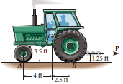

Fig. 2

Q3. The mine car and its contents have a total mass of 6 Mg and a center of gravity at *G*. If the coefficient of static friction between the wheels and the tracks is µ*s* = 0.4 when the wheels are locked, find the normal force acting on the front wheels at *B* and the rear wheels at *A* when the brakes at both *A* and *B* are locked. Does the car move?

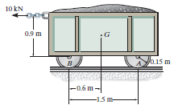

Fig. 3

Ans: Mine car does not move.

Q4. The coefficients of static and kinetic friction between the 100-kg block and the inclined plane are 0.30 and 0.20, respectively. Determine (*a*) the friction force *F* acting on the block when *P* is applied with a magnitude of 200 N to the block at rest, (*b*) the force *P* required to initiate motion up the incline from rest, and (*c*) the friction force *F* acting on the block if *P* = 600 N.

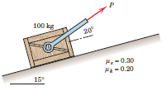



Fig. 4

Ans: (a) F = 66 N, (b) P =516 N, (c) F = 148.5 N.

Q5. Determine the distance *s* to which the 90-kg painter can climb without causing the 4-m ladder to slip at its lower end *A*. The top of the 15-kg ladder has a small roller, and at the ground the coefficient of static friction is 0.25. The mass center of the painter is directly above her feet.

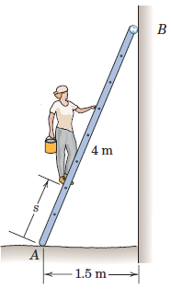

Fig. 5

Ans: 2.55 m